**Name :** Firoz Sheth **Er No:** 1908001070**37**

**Roll No. :** 19CE037

**EXPERIMENT – 1**

**AIM: Implementation of Bubble sort and Selection sort.**

**Bubble sort**

**Input:**

#include <stdio.h>

int main()

{

int i, n, temp, j, arr[10];

printf("\n Enter the number of elements in the array : ");

scanf("%d", &n);

printf("\n Enter the elements: \n");

for(i=0;i<n;i++)

{

scanf("%d", &arr [i]);

}

for(i=0;i<n;i++){

for(j=0;j<n-i-1;j++)

{

if(arr[j] > arr[j+1])

{

temp = arr[j];

arr[j] = arr[j+1];

arr[j+1] = temp;

}

}

}

printf("\n The array sorted in ascending order is(BUBBLE SORT) :\n");

for(i=0;i<n;i++)

printf("%d\t", arr[i]);

//return 0;

}

**OUTPUT:**

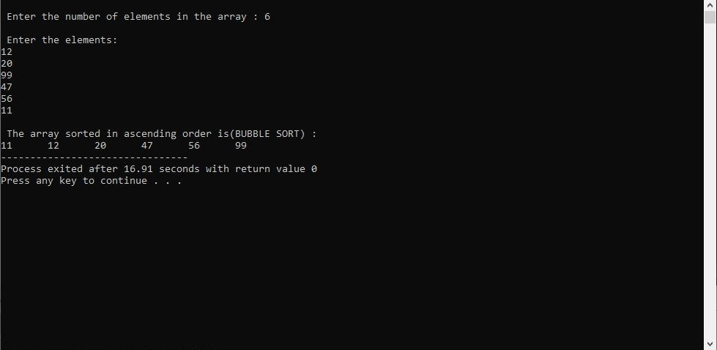

**Selection sort**

**Input:**

#include<stdio.h>

int main(){

int i, j, count, temp, number[25];

printf("\nEnter number of elements: ");

scanf("%d",&count);

printf("\nEnter %d elements: \n", count);

for(i=0;i<count;i++)

scanf(" %d",&number[i]);

for(i=0;i<count;i++){

for(j=i+1;j<count;j++){

if(number[i]>number[j]){

temp=number[i];

number[i]=number[j];

number[j]=temp;

}

}

}

printf("\nSorted elements(SELECTION SORT): ");

for(i=0;i<count;i++)

printf(" %d",number[i]);

return 0;

}

**OUTPUT:**

